What people don’t get about ‘Black Twitter’
By Jeff Guo
October 22, 2015

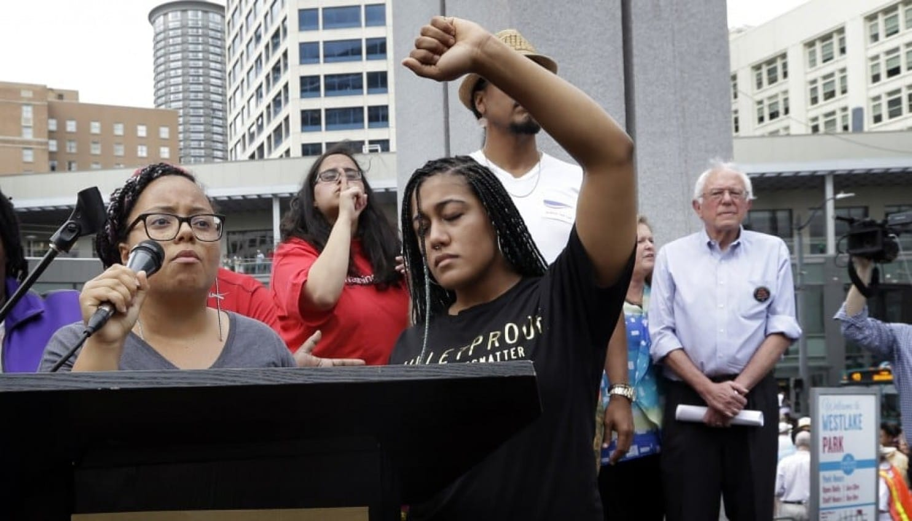
Marissa Johnson, left, speaks as Mara Jacqueline Willaford holds her fist overhead and Democratic presidential candidate Sen. Bernie Sanders, I-Vt., stands nearby as the two women take over the microphone at a rally Saturday, Aug. 8, 2015, in downtown Seattle. (AP Photo/Elaine Thompson)

Twenty years ago, the nation was in a fever over the digital divide.
The Web was still a privileged space, and there was widespread concern that minorities would be left behind as communities — and opportunities — moved online. A Pew Research Center poll from 1998 showed that white Americans were nearly twice as likely as black Americans to use the Internet.
Speaking at MIT in 1998, President Bill Clinton urged students to fight for democracy on the Web. “History teaches us that even as new technologies create growth and new opportunity, they can heighten economic inequalities and sharpen social divisions,” he warned.
It’s no small irony, then, that the Internet has become something of a cradle for black culture and black causes, connecting far-flung communities and amplifying activist voices.
The Black Lives Matter movement started as a Twitter hashtag before it became a full-blown political movement and a major issue in the 2016 presidential race. It is hard to imagine Democratic candidate Hillary Rodham Clinton sitting down with Black Lives Matter activists in August without the mobilizing power of social media. Likewise, the Justice Department in December opened an investigation of the choking death of Eric Garner in New York in response to the popular outrage that had rallied around the battle cry #icantbreathe.
“This would never have happened before,” said Meredith Clark, a professor at the University of North Texas who studies black online communities.
“When, in the past, would a politician have had a meeting with activists — not with political actors, not with leaders in a certain community, not with clergy — but with people who are actively agitating for reform, who are saying with their own mouths that black lives matter?”
Clark is one of a handful of researchers who have been tracing the growth of black communities on the Internet as the digital divide continues to narrow. These days, racial disparities in Internet use have essentially vanished for younger Americans. In 2013, a Pew survey showed that among those younger than 50, there was no significant difference between the rates at which black and white people accessed the Web. (Pew also showed that two-thirds — 68 percent — of Latino Internet users said they used Facebook, Twitter or other social networking sites.)
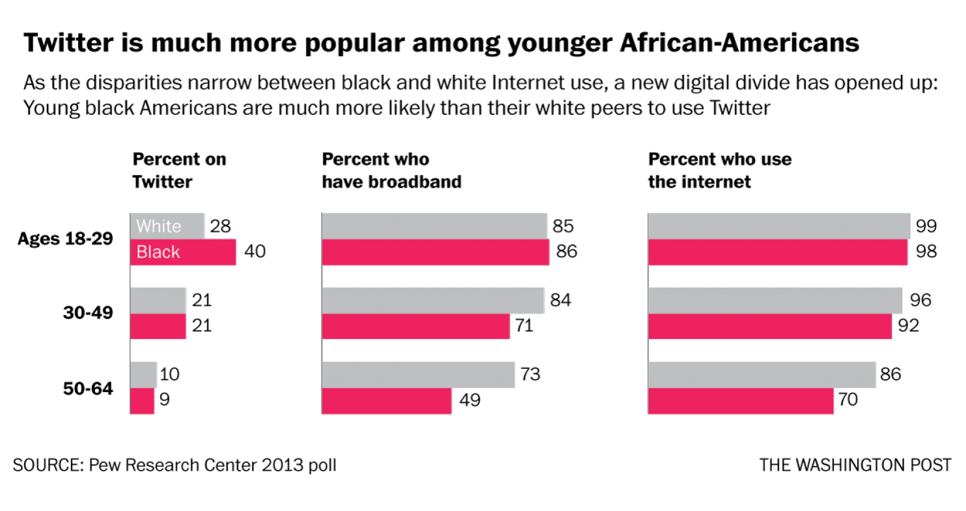
One key reason why minorities and underserved populations have made inroads on social media is the plummeting price of technology. No one could have foreseen the egalitarian effects of the smartphone, which brought cheap Internet access to poor communities.
“It revolutionized access,” says Dayna Chatman, a PhD student at the University of Southern California who studies black culture online. “A lot of the conversations about the digital divide were about who could afford Internet at home. But instead, people were getting online using their phones.”
Even if you couldn’t afford a data plan, Chatman says, even if you didn’t have the Internet at home, you could hop on the WiFi network at a McDonald’s or a Starbucks and be connected.
Black households still lag behind white households in terms of broadband access, but black teenagers have long been more likely than their white counterparts to own smartphones. Young black Americans have particularly embraced social media platforms, which were some of the earliest sites that tailored themselves to mobile users.
According to the Pew survey from 2013, 40 percent of black Internet users ages 18 to 29 said they were on Twitter, compared with 28 percent of their white peers.
By 2009, it was becoming hard for the world to ignore the vigorous minority communities forming online. There have long been black blogs and black Web forums, but on social media, the communication was more intimate, more immediate — and also more visible to the mainstream.
“At the risk of getting randomly harshed on by the Internet, I cannot keep quiet about my obsession with Late Night Black People Twitter, an obsession I know some of you other white people share, because it is awesome,” begins The Awl co-founder Choire Sicha’s 2009 essay about the phenomenon that is now called “Black Twitter.”
Like many, Sicha noticed that hashtags from black Twitter users were regularly showing up on Twitter’s list of trending topics. The social network’s algorithms had no concept of the racial divide. Popular was popular, and Black Twitter was flagrantly so.
Twitter hashtags “brought the activities of tech literate Blacks to the mainstream attention, contravening popular conceptions of Black capitulation to the digital divide,” writes André Brock, a professor of information science at the University of Iowa. Nobody could say that the Internet was an exclusively white space anymore.
Writing for Slate in 2010, technology columnist Farhad Manjoo attempted to analyze how black culture had become so prominent on Twitter. There was, of course, the sheer volume of people and tweets. But Manjoo observed that black users tended to be more socially active than others. “They follow one another more readily, they retweet each other more often, and more of their posts are @-replies — posts directed at other users,” he wrote.
Clark, the University of North Texas professor, interviewed dozens of prominent black Twitter users for her doctoral dissertation. If online black communities seem especially tight-knit, she says, that’s because most of them grew out of already tight-knit relationships in real life, within the context of an already tight-knit culture.
When mainstream journalists started to “discover” Black Twitter five years ago, they were seeing conversations that had always been alive in black America — but in segregated spaces, such as black barbershops and black hair salons, black colleges and black churches. Twitter offered the possibility of anonymous surveillance. White people don’t tend to venture into black salons, but anyone can click on a trending black hashtag and observe black communities at close proximity.
On Reddit, there is even a group of more than half a million members devoted to collecting “screenshots of black people being hilarious on social media.” It’s unclear how many of these Reddit users are black, but probably not many, because Rule No. 8 of the group warns members: “Do not add ‘bruh’ or ‘fam’ or similar vernacular to your post or comment just to sound black.”
But members of the black community did not hop on social networks to be gawked at or to gain attention. They don’t tweet for the sake of teaching outsiders about black culture. They use the Internet for the same reason everyone else does: to be connected.
“I’ve heard from people who were very isolated, where they were one of very few black people in their communities,” Clark says. “For them, being able to log into Twitter, to talk to hundreds or thousands of people sharing the same background — that provided a great deal of relief.”
And so it begins to seem like a violation when these private-yet-public conversations become objects of voyeurism. As much as the Internet has become an essential tool for mobilizing black activism, as much as it has educated outsiders about black culture, as much as it has afforded black voices a political platform, online spaces can also sometimes feel like a zoo.
“It’s not that we don’t want to celebrate our visibility,” said Chatman, the USC researcher. “Our visibility brings a certain amount of power. But we are wary that it can easily be co-opted, reconfigured in a certain way that we didn’t intend. There’s tension over the lack of control over our own narrative.”
This is why many have begun to take offense at the term Black Twitter. To attach a label to the phenomenon is to imply that it is somehow secondary. It’s a subtle way of making black people on Twitter feel segregated.
As Clark recalls one prominent user telling her: “Black Twitter is just Twitter.”

Jeff Guo was a reporter covering economics, domestic policy and everything empirical. He left The Washington Post in April 2017.

